Conditional Formatting

1. Stacked column chart

**Insights:**

* Here we are creating the visuals for sum of sales by product.
* Sum of sales is represented in different colors based on product performance in sales.
* Every product have different colors.
* In this visuals Paseo have more sales compare to other products.
* X-axis having Product.
* Y-axis having Sum of sales.

**Visualization:**

* Build visual and format visual
* X-axis > Product(Drag)
* Y-Axis>Sales(Drag)
* Visualizations> General> Effect> Background>on>FX(Conditional formatting)
* Format style > Gradient > Select field > All data > sales > Summarization > Sum
* Minimum > Red
* Maximum > Blue
* Minimum > Yello

1. Stacked Bar chart.

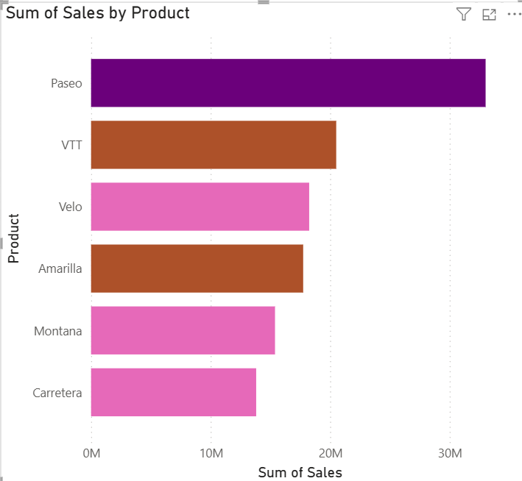

**Insights:**

* Here we are creating the visuals for sum of sales by product.
* Sum of sales is represented in different colors based on product performance in sales.
* Every product have different colors.
* In this visuals Paseo have more sales compare to other products.
* X-axis having Product.
* Y-axis having Sum of sales.

**Visualization:**

* Build visual and format visual
* X-axis > Product (drag)
* Y-axis > Sales (Drag)
* Visualizations> General >Bars>Color>FX(conditional format)
* Format style > Rules > Select field > Sum of profit > Summarization > Sum
* Rules > If value> >= 350000 > Number > and > <= 5000000 > Number > then> Color >Purple
* New rule> If value> >= 2500000> Number> and> <= 3500000>number>Then>colour>Orange
* New rule> If value> >= 1500000> Number> and> <= 2500000>number>Then>colour>Pink

**Filter**

Create a charts to represent product wise profit for each discount band

**Insights:**

* Here we are creating the visuals for sum of Profit by Product and Discount Band Filter for each level.
* We have to create each level visual separately.
* Discount Band is represented in High,Low,Medium and None Performance.
* First Visual shows High Discount Band Profit value.
* Second Visual shows Low Discount Band Profit value.
* Third Visual shows Medium and
* Fourth visual shows None.
* Low Discount Band have highest Profit compared with other three visuals

**Visualization:**

* Build visual and format visual
* **Click on Stacked column chart**
* Create four chart and Drop Product in X-axis and Drop Profit to Y-axis in every charts.
* Make shore Profit values has to be Sum.
* Than Drop Discount band to X-axis After the Product.
* After creating Four visuals Select Data Labels that we can easily analyse Profit value.
* Filters>Discount Band > Select High, Low, Medium and None for each visuals.

**Small Multiples**

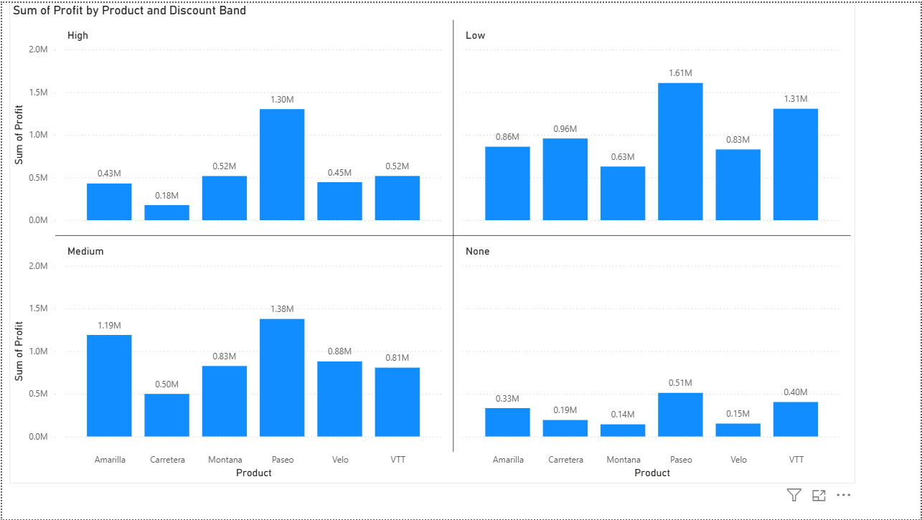

**Insights:**

* Here we are Creating the visual for Sum of Profit by product and discount band for each level in Single Visual.
* Here we cant able to change any visual particularly.
* In this visual Low Discount band have more profit.
* In single shot we can create this Visual.

**Visualization:**

* Build visual and format visual
* Click on stacked column chart
* For X-axis Drop Product.
* For Y-axis Drop Profit (Make shore values should be in sum).
* Drop Discount Band for Small multiples.
* Format your visual > Data labels > On

**Basic Introduction Questions on Power BI**

1. **What is Power BI?**

**Introduction**

* Power BI is a business analytics tool by Microsoft designed to turn raw data into visually compelling interactive reports and dashboards.
* It empowers organizations and individuals to make informed, data-driven decisions quickly.

**Workflow: From Data to Decision**

1. **Connect:** Import and combine data sources.
2. **Transform:** Clean and model your data.
3. **Visualize:** Build interactive charts and dashboard tiles.
4. **Publish & Share:** Collaborate online or via mobile apps.
5. **Act:** Make data-informed decisions with real-time insights.

**Real-World Impact**

* Used for performance tracking, strategic planning, market analysis, sales & operations management.
* Scales from small teams to entire enterprises, with robust governance and compliance features.
* Artificial Intelligence (AI) enhances data exploration and reporting efficiency.

1. **Who developed Power BI?**

**Power BI was developed by Microsoft**, with significant contributions from visionaries such as Thierry D'Hers and Amir Netz of the SQL Server Reporting Services team. The original design work was led by Ron George in 2010 as "Project Crescent," which later evolved through several internal Microsoft initiatives before its public launch in 2013 and general release in 2015.

**Historical Development**

* Power BI originated from Microsoft Excel add-ins: Power Pivot, Power Query, and Power View, created to enable advanced analytics and visualization.
* Thierry D'Hers and Amir Netz played key roles in the conception and vision behind Power BI, driving its evolution from early BI technologies at Microsoft into a standalone, cloud-based analytics platform.
* The official release of Power BI as a distinct product was in July 2015, following its initial unveiling for Office 365 in 2013.

**Key Contributors**

* **Thierry D'Hers:** Early concept and promotion of BI technologies within Microsoft.
* **Amir Netz:** Technical Fellow and CTO of Power BI, a founding visionary for the product direction.youtube
* **Ron George:** Designed first iteration as Project Crescent in 2010.

Power BI has since become a centerpiece of the Microsoft Power Platform, offering cloud-based and desktop solutions for modern business intelligence needs

1. **Why do we use Power BI?**

**Introduction**

* Power BI is a leading business analytics solution designed to turn complex data into easy-to-understand, actionable insights for organizations of all sizes.

**1. Data Visualization & Insights**

* Create visually rich dashboards, charts, and reports that simplify decision-making and highlight business trends at-a-glance.
* Interactive graphics make analyzing and sharing results straightforward.

**2. Integration & Accessibility**

* Seamlessly connects to hundreds of data sources: Excel, SQL, cloud platforms, APIs, and more.
* Access dashboards and insights from anywhere via desktop, web, or mobile apps.

**3. Real-Time Analytics**

* Monitor key metrics and business performance in real-time for faster, smarter responses.
* Live data refreshes ensure decision-makers act on the latest information.

**4. Collaboration & Sharing**

* Share dashboards securely across teams for improved communication and collective decision-making.
* Easy integration with Microsoft Teams, PowerPoint, and external platforms.

**5. Customization & Automation**

* Customizable dashboards let users track specific KPIs and automate data updates without manual effort.
* Personalize data views based on unique business roles or goals.

**6. Enhanced Security & Compliance**

* Built-in security features and compliance support make Power BI suitable for sensitive and regulated data environments.

1. **What are the main components of Power BI?**

Power BI is a comprehensive analytics platform consisting of several core components that work together to enable business intelligence—connecting, transforming, visualizing, and sharing data across your organization.

**Key Components**

**1. Power BI Desktop**

* Desktop application for building, modeling, and visualizing reports.
* Enables connections to diverse data sources (Excel, databases, cloud) and offers advanced analytical features.

**2. Power BI Service**

* Cloud platform for publishing, sharing, and collaborating on Power BI reports and dashboards.
* Provides secure access to analytics from any device, supports real-time refresh, and team communication.

**3. Power BI Mobile Apps**

* Mobile applications for Android, iOS, and Windows.
* Offers on-the-go access to reports and dashboards for decision-making anywhere.

**4. Power Query**

* Data connection and transformation tool included in Desktop and Service.
* Cleans, merges, and shapes data before analysis; supports connections to multiple sources.

**5. Power Pivot**

* Data modeling engine for creating advanced calculations and aggregations using DAX.
* Handles large datasets and creates relationships between data tables for deep analytics.

**6. Power View**

* Visualization feature for creating interactive charts, graphs, and maps within Power BI reports.
* Facilitates real-time exploration and story-telling with data

1. **What is Power BI Desktop?**

Power BI is a free Windows application from Microsoft that allows users to **connect, transform, model, and visualize data** to create insightful reports and dashboards.

**Key Features**

**1. Data Connectivity**

* Connects to over 100 data sources including Excel, SQL Server, cloud services, and web data.
* Enables importing data from both on-premises and cloud sources with ease.

**2. Data Transformation (Power Query)**

* Built-in Power Query Editor allows cleaning, shaping, and transforming raw data without coding.
* Easily merge multiple data tables and prepare data for analysis.

**3. Data Modeling**

* Create relationships between data tables.
* Generate calculated columns and measures using DAX, a powerful formula language.
* Supports large datasets with optimized performance.

**4. Rich Visualizations**

* Offers 30+ built-in charts, graphs, maps, and supports custom visuals.
* Interactive drag-and-drop canvas to design reports intuitively.

**5. Advanced Analytics and AI**

* Use features like quick measures, forecasting, and clustering.
* Integrated AI capabilities to automatically find patterns and generate insights without code.

**6. Report Sharing**

* Publish reports to the Power BI Service for sharing and collaboration.
* Create mobile-optimized reports accessible on any device.

1. **What is Power BI Service?**

**Introduction:**

* **Power BI Service**is a cloud-based business analytics service by Microsoft.
* It allows users to publish, share, collaborate, and consume reports and dashboards online from anywhere.

**Core Features**

**1. Collaboration & Sharing**

* Share interactive reports and dashboards with team members and stakeholders securely.
* Organize content in workspaces and distribute via apps for streamlined access.

**2. Real-Time Dashboards**

* Monitor key business metrics live with dashboards that update in real-time.
* Support for streaming data sources enables instant insights.

**3. Dataflows and Datasets**

* Centralize data preparation and transformation with reusable dataflows.
* Share datasets across reports to ensure consistent data usage.

**4. Scheduling & Alerts**

* Automate data refresh to keep data current.
* Set alerts to get notified when important thresholds are met.

**5. Advanced Security**

* Supports row-level security, encryption, sensitivity labels.
* Detailed audit logs and usage metrics to monitor access and performance.

**6. Integration & Embedding**

* Embed reports in Microsoft apps like Teams, SharePoint, and PowerPoint.
* Use APIs to integrate Power BI visuals into custom applications.

1. **What is Power BI Mobile?**

**Introduction:**

* Power BI Mobile is Microsoft’s mobile application for accessing, viewing, and interacting with Power BI reports and dashboards on smartphones and tablets across platforms like iOS, Android, and Windows.

**Key Features**

**1. Access Anywhere, Anytime**

* View live Power BI dashboards and reports securely from mobile devices, enabling data-driven decisions on the go.

**2. Interactive Data Experience**

* Supports filtering, drilling down, cross-highlighting, and touch-optimized navigation for seamless interaction with visuals on small screens.

**3. Offline Viewing**

* Access previously viewed reports and dashboards even without internet connectivity (with some limited interactivity).

**4. Location-Based Reporting**

* Filter report data based on current geographic location for contextually relevant insights, ideal for fieldwork and regional analysis.

**5. Barcode and QR Code Scanning**

* Scan barcodes or QR codes to quickly pull up related reports and data without manual searching.

**6. Alerts & Notifications**

* Set data alerts to receive push notifications when important metrics change or thresholds are met.

**7. Annotations & Collaboration**

* Add notes, comments, and markups directly on reports to facilitate team communication while mobile.

**8. Integration with Microsoft Intune**

* Enhanced security and management of the app on corporate devices with features like data encryption and controlled access

1. **What is the difference between Power BI Desktop and Power BI Service?**

**Overview:**

Both are key components of the Power BI ecosystem but serve different purposes:

* **Power BI Desktop: A free, Windows-based desktop application for data modeling, transformation, and report creation.**
* **Power BI Service: A cloud-based, web platform for publishing, sharing, collaboration, and consumption of reports and dashboards.**

**Purpose & Use Cases:**

|  |  |  |
| --- | --- | --- |
| Aspect | Power BI Desktop | Power BI Service |
| Primary Use | Build and design reports and data models | Share, collaborate, and consume reports |
| Platform Type | Desktop application (local Windows) | Online cloud-based service |
| Data Connectivity | Connect to 100+ data sources | Limited direct data modeling, focuses on sharing and light editing |
| Data Modeling | Advanced DAX formulas, relationships | Basic modeling, dataflows for preparation |
| Collaboration | Minimal (file sharing) | Extensive real-time collaboration |
| Data Refresh | Manual refresh | Scheduled/automatic refresh |
| Accessibility | Windows only | Accessible from any browser or device |
| Integration | Strong with Excel and local tools | Integrates with Microsoft 365, Teams, SharePoint |
| Cost | Free | Requires Pro or Premium license for full features |

**Feature Highlights:**

|  |  |  |
| --- | --- | --- |
| Aspect | Power BI Desktop | Power BI Service |
| Primary Use | Build and design reports and data models | Share, collaborate, and consume reports |
| Platform Type | Desktop application (local Windows) | Online cloud-based service |
| Data Connectivity | Connect to 100+ data sources | Limited direct data modeling, focuses on sharing and light editing |
| Data Modeling | Advancedâ€”DAX formulas, relationships | Basic modeling, dataflows for preparation |
| Collaboration | Minimal (file sharing) | Extensive real-time collaboration |
| Data Refresh | Manual refresh | Scheduled/automatic refresh |
| Accessibility | Windows only | Accessible from any browser or device |
| Integration | Strong with Excel and local tools | Integrates with Microsoft 365, Teams, SharePoint |
| Cost | Free | Requires Pro or Premium license for full features |

**Use Power BI Desktop for:**

* + **Advanced data preparation and modeling.**
  + **Developing detailed reports offline.**
  + **Initial creation and local experimentation.**

**Use Power BI Service for:**

* + **Distributing and sharing reports enterprise-wide.**
  + **Collaboration and team-based analytics.**
  + **Scheduled data refresh and real-time dashboards.**

1. **What are the key features of Power BI?**

**Key Features of Power BI**

**1. Data Connectivity and Integration**

* Connects to 100+ data sources including databases, cloud services, spreadsheets, and web sources.
* Supports hybrid deployment with connectors for Microsoft and third-party sources.
* Utilizes Power Query for self-service data preparation and transformation.

**2. Data Modeling and Calculation**

* Robust data modeling using Data Analysis Expressions (DAX) formulas.
* Supports calculated columns, tables, and relationships for complex data scenarios.
* Features a modeling view for better organization and management of data models.

**3. Advanced Visualizations and Reporting**

* Over 30 built-in and custom visual types like charts, graphs, maps, and KPIs.
* Interactive, real-time dashboards with automatic data refresh.
* Includes modern tooltips, matrix layouts, and custom report themes.

**4. Artificial Intelligence Integration**

* AI-driven features like image recognition, text analytics, and natural language Q&A.
* Integration with Azure Machine Learning and upcoming AI-powered Copilot for advanced insights.

**5. Collaboration and Sharing**

* Workspaces and apps for team collaboration and report distribution.
* Secure sharing with row-level security (RLS), sensitivity labels, and audit logs.
* Email subscriptions, alerts, and embedding capabilities.

**6. Real-Time and Streaming Analytics**

* Real-time dashboard views for live data monitoring.
* Stream analytics for timely decision-making across industries.

**7. Customization and Extensibility**

* Developers can customize visual appearance and import new visuals.
* APIs available for integrating Power BI dashboards into other applications.

**8. Mobile and Accessibility**

* Power BI mobile app for accessing reports and dashboards anywhere.
* User-friendly design to enable non-technical users to create and analyze reports.

1. **What types of data sources can Power BI connect to?**

**Power BI Data Sources**

**1. File-Based Data Sources**

* Excel Workbooks
* CSV, XML, JSON files
* PDF, Parquet files
* Folder data (multiple files in a folder)

**2. Database Data Sources**

* SQL Server, SQL Server Analysis Services
* Oracle, MySQL, PostgreSQL, MariaDB
* IBM Db2, IBM Informix, IBM Netezza
* Sybase, Teradata, SAP HANA, SAP Business Warehouse
* Amazon Redshift, Amazon Athena
* Google BigQuery, Google Sheets (Beta)
* Snowflake, Vertica, Impala, Exasol, Actian (Beta)
* Other Databases including Teradata, Denodo, Dremio, and more

**3. Cloud Services Data Sources**

* Azure SQL Database, Azure Synapse Analytics
* Azure HDInsight Spark
* Microsoft Fabric components like Dataflows, Datamarts, Warehouses, Lakehouses

**4. Power Platform Data Sources**

* Power BI datasets and dataflows
* Dataverse (Common Data Service)
* Power Platform tables and data collections

**5. Online Services and Applications**

* SharePoint Online, Microsoft Exchange Online
* Dynamics 365 (multiple versions)
* Salesforce Objects and Reports
* Google Analytics, Adobe Analytics
* GitHub, LinkedIn Sales Navigator (Beta)
* Many other SaaS platforms for marketing, sales, project management, finance

**6. Other Data Sources**

* Web data via URL or OData feed
* Active Directory, Hadoop File System, Spark, Hive LLAP
* R and Python scripts
* ODBC and OLE DB connectors
* Bloomberg, SurveyMonkey, Microsoft Teams Analytics (Beta), and more.

1. **What is a visualization in Power BI?**

**Definition**

* A **visualization** (or visual) is a graphical representation of data.
* It transforms raw data into charts, graphs, maps, and other visual formats to make data easier to understand and analyze.

**Purpose**

* Helps to identify patterns, trends, and insights quickly.
* Facilitates data-driven decision-making with clear visuals.
* Enhances communication of complex data through intuitive imagery.

**Common Visualization Types in Power BI**

* **Bar and Column Charts:** Compare values across categories.
* **Line Charts:** Show data trends over time.
* **Pie and Doughnut Charts:** Display part-to-whole relationships.
* **Funnel Charts:** Visualize sequential stages in a process.
* **Gauge Charts:** Show progress toward a goal or KPI.
* **Treemaps:** Represent hierarchical data with nested rectangles.
* **Waterfall Charts:** Show cumulative changes over time.
* **Maps:** Display geographical data points for spatial analysis.
* **Cards:** Highlight single key metrics or numbers.
* **Combo Charts:** Combine multiple chart types in one visual.

**Interactivity**

* Visuals in Power BI are interactive, allowing users to filter, drill down, and explore the data dynamically.